**IT163-1: Synthesize database design Concepts**

**IT163-1: Synthesize database design Concepts**

**Introduction**

In this assignment, we have undertaken the task of designing a comprehensive database for Fit @ Home. This home gym concierge service offers equipment subscription packages and personalized training sessions in the comfort and safety of one's home. The assignment focuses on various crucial database design concepts, such as conceptual modelling, normalization, and creating a logical and physical data model. The goal is to organize the disorganized data into an efficient and structured database system that will enable Fit @ Home to manage its operations effectively and support its business growth.

Throughout the assignment, we carefully examined the provided data, identified entities, defined attributes, and established relationships to construct a robust conceptual model. Subsequently, we followed the normalization process to ensure that the database design adhered to the First, Second, and Third Normal Forms principles, thereby eliminating data redundancy and maintaining data integrity. Moreover, we extended the logical model by introducing additional tables and refining the relationships, culminating in a detailed physical model.

**Conceptual Model (Module 1 Assessment Part 1)**

Below is the definition of the attributes for each entity to be used to create the Entity-Relationship Diagram (ERD) using Crow's Foot Database Notation.

***Entities, their Attributes and Relationships***

1. ***Entities and their Attributes***
2. *Members*
3. MemberID (Primary Key)
4. Name
5. Phone
6. Address
7. MembershipStatus
8. *Trainers*
9. TrainerID (Primary Key)
10. Name
11. Specialty
12. *Equipment*
13. EquipmentID (Primary Key)
14. Name
15. QuantityAvailable
16. *Training*
17. TrainingID (Primary Key)
18. Type
19. ***Relationships***
20. *Members and Equipment (one-to-many)*

* Members have a relationship with Equipment.
* Members can have multiple Equipment.
* Each piece of Equipment can belong to only one Member.

1. *Members and Trainers (many-to-many)*

* Members have a relationship with Trainers.
* Members can have multiple Trainers.
* Trainers can have various Members.

1. *Members and Training (one-to-many)*

* Members have a relationship with Training.
* Members can attend multiple Training sessions.
* Each Training session is associated with only one Member.

1. *Trainers and Training (one-to-many)*

* Trainers have a relationship with Training.
* Trainers can conduct multiple Training sessions.
* Only one Trainer conducts each Training session.

1. *Equipment and Training (many-to-many)*

* Equipment has a relationship with Training.
* Equipment can be used in multiple Training sessions.
* Each Training session may involve multiple Equipment.

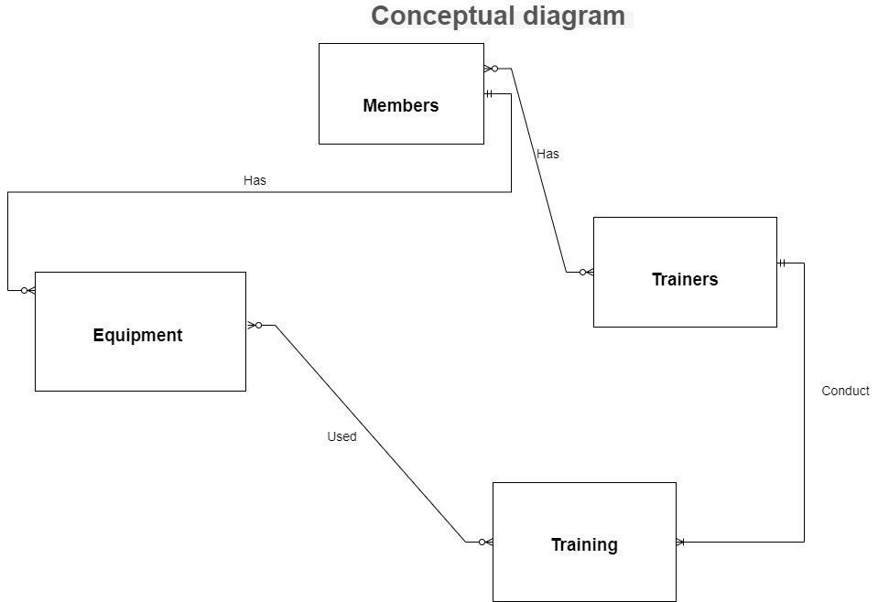

**Normalization (Module 1 Assessment Part 2)**

To normalize the data to the third standard form (3NF), we must go through the step-by-step normalization process and address any issues in the first, second, and third typical forms (Harrington, 2016). The normalization process is as follows:

***Step 1: First Normal Form (1NF)***

In this step, we eliminate repeating groups and ensure that each attribute has atomic values.

*Table: Members*

|  |  |  |  |  |
| --- | --- | --- | --- | --- |
| **MemberID (PK)** | **Name** | **Phone** | **Address** | **MembershipStatus** |
| 1 | Fred Brown | 555-123-9281 | 123 Main Street | Bronze Status |
| 2 | Jennifer Walters | 555-282-2820 | 15 Stone Lane | Bronze Status |
| 3 | Melanie Smith | 555-509-3936 | 75 Lokey Avenue | Gold Status |
| 4 | Jeff Smith | 555-338-2820 | 7355 Oak Mountain Dr | Silver Status |
| 5 | Fred Brown | 555-822-8809 | 88 Grand Pine Dr | Silver Status |
| 6 | Tamara Rohly | 555-838-3830 | 900 Friendship Loop | Bronze Status |

*Table: Equipment*

|  |  |
| --- | --- |
| **EquipmentID (PK)** | **Name** |
| 1 | Barbells |
| 2 | Elliptical |
| 3 | Kettle Bells |
| 4 | Exercise Ball |
| 5 | Rower |
| 6 | Recumbent Bike |
| 7 | Treadmill |

*Table: Trainers*

|  |  |  |
| --- | --- | --- |
| **TrainerID (PK)** | **Name** | **Specialty** |
| 1 | Strength | Molly |
| 2 | Cardio | Shawn |
| 3 | Yoga | Sasha |
| 4 | Strength | James |
| 5 | Cardio | Amelia |
| 6 | Yoga | Brian |
| 7 | Cardio | Jon |
| 8 | Yoga | Calvin |
| 9 | Strength | Kevin |

*Table: Training*

|  |  |
| --- | --- |
| **TrainingID (PK)** | **Type** |
| 1 | Strength |
| 2 | Cardio |
| 3 | Yoga |

*Table: Members_ Equipment (Join Table for Many-to-Many Relationship)*

|  |  |
| --- | --- |
| **MemberID (FK)** | **EquipmentID (FK)** |
| 1 | 1 |
| 2 | 2 |
| 3 | 2 |
| 3 | 3 |
| 3 | 4 |
| 4 | 5 |
| 4 | 6 |
| 5 | 5 |
| 5 | 6 |
| 6 | 6 |

*Table: Members_Trainers (Join Table for Many-to-Many Relationship)*

|  |  |
| --- | --- |
| **MemberID (FK)** | **TrainerID (FK)** |
| 1 | 1 |
| 2 | 2 |
| 3 | 1 |
| 3 | 3 |
| 4 | 2 |
| 5 | NULL |
| 6 | 3 |

***Step 2: Second Normal Form (2NF)***

This step removes partial dependencies by identifying and creating separate tables for entities with composite primary keys. The Members table already has a single-column primary key (MemberID), so it is already in 2NF.

*Table: Equipments*

|  |  |
| --- | --- |
| **EquipmentID (PK)** | **Name** |
| 1 | Barbells |
| 2 | Elliptical |
| 3 | Kettle Bells |
| 4 | Exercise Ball |
| 5 | Rower |
| 6 | Recumbent Bike |
| 7 | Treadmill |

*Table: Trainers*

|  |  |  |
| --- | --- | --- |
| **TrainerID (PK)** | **Name** | **Specialty** |
| 1 | Strength | Molly |
| 2 | Cardio | Shawn |
| 3 | Yoga | Sasha |
| 4 | Strength | James |
| 5 | Cardio | Amelia |
| 6 | Yoga | Brian |
| 7 | Cardio | Jon |
| 8 | Yoga | Calvin |
| 9 | Strength | Kevin |

*Table: Training*

|  |  |
| --- | --- |
| **TrainingID (PK)** | **Type** |
| 1 | Strength |
| 2 | Cardio |
| 3 | Yoga |

***Step 3: Third Normal Form (3NF)***

In this step, we remove transitive dependencies and create separate tables for entities with non-key attributes. The Members table already has a different table for Equipment (Members_Equipment) and Trainers (Members_Trainers), so it is already in 3NF.

*Table: Members*

|  |  |  |  |  |
| --- | --- | --- | --- | --- |
| **MemberID (PK)** | **Name** | **Phone** | **Address** | **MembershipStatus** |
| 1 | Fred Brown | 555-123-9281 | 123 Main Street | Bronze Status |
| 2 | Jennifer Walters | 555-282-2820 | 15 Stone Lane | Bronze Status |
| 3 | Melanie Smith | 555-509-3936 | 75 Lokey Avenue | Gold Status |
| 4 | Jeff Smith | 555-338-2820 | 7355 Oak Mountain Dr | Silver Status |
| 5 | Fred Brown | 555-822-8809 | 88 Grand Pine Dr | Silver Status |
| 6 | Tamara Rohly | 555-838-3830 | 900 Friendship Loop | Bronze Status |

*Table: Members_Equipment (Join Table for Many-to-Many Relationship)*

|  |  |
| --- | --- |
| **MemberID (FK)** | **EquipmentID (FK)** |
| 1 | 1 |
| 2 | 2 |
| 3 | 2 |
| 3 | 3 |
| 3 | 4 |
| 4 | 5 |
| 4 | 6 |
| 5 | 5 |
| 5 | 6 |
| 6 | 6 |

*Table: Members_Trainers (Join Table for Many-to-Many Relationship)*

|  |  |
| --- | --- |
| **MemberID (FK)** | **TrainerID (FK)** |
| 1 | 1 |
| 2 | 2 |
| 3 | 1 |
| 3 | 3 |
| 4 | 2 |
| 5 | NULL |
| 6 | 3 |

*Table: Equipment*

|  |  |
| --- | --- |
| **EquipmentID (PK)** | **Name** |
| 1 | Barbells |
| 2 | Elliptical |
| 3 | Kettle Bells |
| 4 | Exercise Ball |
| 5 | Rower |
| 6 | Recumbent Bike |
| 7 | Treadmill |

*Table: Trainers*

|  |  |  |
| --- | --- | --- |
| **TrainerID (PK)** | **Name** | **Specialty** |
| 1 | Strength | Molly |
| 2 | Cardio | Shawn |
| 3 | Yoga | Sasha |
| 4 | Strength | James |
| 5 | Cardio | Amelia |
| 6 | Yoga | Brian |
| 7 | Cardio | Jon |
| 8 | Yoga | Calvin |
| 9 | Strength | Kevin |

*Table: Training*

|  |  |
| --- | --- |
| **TrainingID (PK)** | **Type** |
| 1 | Strength |
| 2 | Cardio |
| 3 | Yoga |

The data has been normalized to the third standard form (3NF) by following the step-by-step process and creating separate tables for each entity with appropriate primary keys and attributes.

**Logical Model (Module 1 Assessment Part 3)**

***Logical ERD Description***

***Entities***

1. **Members**
2. MemberID (Primary Key)
3. Name
4. Phone
5. Address
6. MembershipStatus
7. **Equipment**
8. EquipmentID (Primary Key)
9. Name
10. Quantity Available
11. **Trainers**
12. TrainerID (Primary Key)
13. Name
14. Specialty
15. *Training*
16. TrainingID (Primary Key)
17. Type

***Relationships***

1. *Members and Equipment (one-to-many)*
2. Members have a relationship with Equipment.
3. Members can have multiple Equipment.
4. Each piece of Equipment can belong to only one Member.
5. Foreign Key: MemberID in the Equipment table referencing MemberID in the Members table.
6. *Members and Trainers (many-to-many)*
7. Members have a relationship with Trainers.
8. Members can have multiple Trainers.
9. Trainers can have multiple Members.
10. Here a new table Members_Trainers is created to handle the many-to-many relationship.
11. Foreign Keys: MemberID in the Members_Trainers table referencing MemberID in the Members table, and TrainerID in the Members_Trainers table referencing TrainerID in the Trainer’s table.
12. *Members and Training (one-to-many)*
13. Members have a relationship with Training.
14. Members can attend multiple Training sessions.
15. Each Training session is associated with only one Member.
16. Foreign Key: MemberID in the Training table referencing MemberID in the Members table.
17. *Trainers and Training (one-to-many)*
18. Trainers have a relationship with Training.
19. Trainers can conduct multiple Training sessions.
20. Only one Trainer conducts each Training session.
21. Foreign Key: TrainerID in the Training table referencing TrainerID in the Trainer’s table.
22. *Equipment and Training (many-to-many)*
23. Equipment has a relationship with Training.
24. Equipment can be used in multiple Training sessions.
25. Each Training session may involve multiple Equipment.
26. A new table Equipment_Training is created to handle the many-to-many relationship.
27. Foreign Keys: EquipmentID in the Equipment_Training table referencing EquipmentID in the Equipment table, and EquipmentID in the Equipment_Training table referencing TrainingID in the Training table.

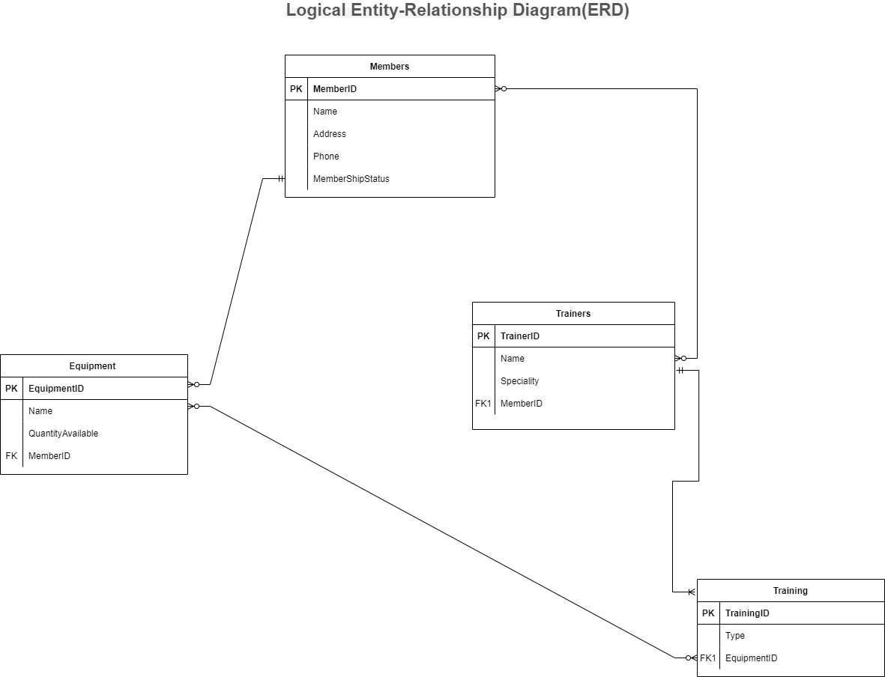

**Physical Model (Module 1 Assessment Part 4)**

***Physical ERD Description***

***Entities***

1. **Members**
2. MemberID (Primary Key) [Data Type: INT, Field Size: 10]
3. Name [Data Type: VARCHAR, Field Size: 100]
4. Phone [Data Type: VARCHAR, Field Size: 15]
5. Address [Data Type: VARCHAR, Field Size: 200]
6. MembershipStatus [Data Type: VARCHAR, Field Size: 50]
7. **Equipment**
8. EquipmentID (Primary Key) [Data Type: INT, Field Size: 10]
9. Name [Data Type: VARCHAR, Field Size: 100]
10. Quantity Available [Data Type: INT, Field Size: 5]
11. **Trainers**
12. TrainerID (Primary Key) [Data Type: INT, Field Size: 10]
13. Name [Data Type: VARCHAR, Field Size: 100]
14. Specialty [Data Type: VARCHAR, Field Size: 50]
15. **Training**
16. TrainingID (Primary Key) [Data Type: INT, Field Size: 10]
17. Type [Data Type: VARCHAR, Field Size: 100]
18. **Members_Equipment** *(Join Table for Many-to-Many Relationship)*
19. MemberEquipmentID (Primary Key) [Data Type: INT, Field Size: 10]
20. MemberID (Foreign Key) [Data Type: INT, Field Size: 10, Nullability: No]
21. EquipmentID (Foreign Key) [Data Type: INT, Field Size: 10, Nullability: No]
22. **Members_Trainers** *(Join Table for Many-to-Many Relationship)*
23. MemberTrainerID (Primary Key) [Data Type: INT, Field Size: 10]
24. MemberID (Foreign Key) [Data Type: INT, Field Size: 10, Nullability: No]
25. TrainerID (Foreign Key) [Data Type: INT, Field Size: 10, Nullability: No]

**Relationships**

1. ***Members and Equipment (one-to-many)***
2. Foreign Key: MemberID in the Equipment table referencing MemberID in the Members table.
3. Foreign Key: EquipmentID in the Members_Equipment table referencing EquipmentID in the Equipment table.
4. ***Members and Trainers (many-to-many)***
5. A new table Members_Trainers is created to handle the many-to-many relationship.
6. Foreign Key: MemberID in the Members_Trainers table referencing MemberID in the Members table.
7. Foreign Key: TrainerID in the Members_Trainers table referencing TrainerID in the Trainers’ table.
8. ***Members and Training (one-to-many)***
9. Foreign Key: MemberID in the Training table referencing MemberID in the Members table.
10. ***Trainers and Training (one-to-many)***
11. Foreign Key: TrainerID in the Training table referencing TrainerID in the Trainers’ table.
12. ***Equipment and Training (many-to-many)***
13. A new table Equipment_Training is created to handle the many-to-many relationship.
14. Foreign Key: EquipmentID in the Equipment_Training table referencing EquipmentID in the Equipment table.
15. Foreign Key: TrainingID in the Equipment_Training table referencing TrainingID in the Training table.

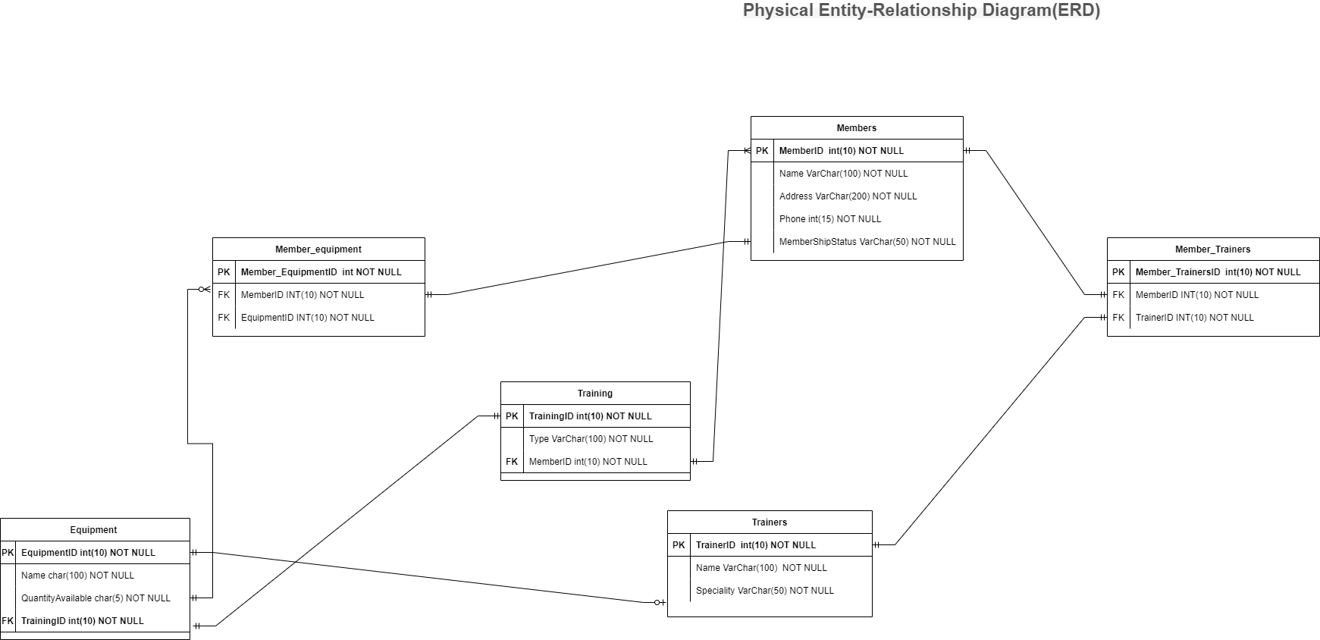

**Conclusion**

Completing this assignment marks a significant achievement in designing a reliable and well-structured database system for Fit @ Home. By thoroughly analyzing the data and applying database design principles, we have successfully transformed the initial archaic and disorganized system into a robust database that efficiently manages member information, equipment inventory, trainer details, and training sessions. Adopting Crow's Foot Database Notation in Microsoft Visio allowed us to create clear and visually appealing Entity-Relationship Diagrams (ERD), effectively representing the entities, attributes, relationships, primary keys, foreign keys, and data types. Furthermore, the newly designed database will empower Fit @ Home to streamline operations, enhance data integrity, and make informed business decisions. The scalable and well-organized structure will facilitate future expansions and modifications to meet the evolving needs of their growing business. This assignment has provided invaluable insights into the importance of thoughtful database design, planning, and prioritization in creating a robust foundation for an organization's data management endeavours.

**References**

Harrington, J. L. (2016). Relational database design and implementation (4th ed.). Morgan Kaufmann Publishers.

 Campbell, J. (2016). Software development fundamentals: Creating entity-relationship diagrams [Video]. Skillsoft.

Sampson, A. (2015). Generic design and modelling databases: Determining relationships in an ERD [Video]. Skillsoft

Ulrich, L. A., & Cook, K. (2018). Access 2019 for dummies.

Green, B. (2016, June 22). Create an ERD in MS Visio [Video]. YouTube. https://www.youtube.com/watch?v＝dwo48lxj1UM